**Briefing Note to the Chief Executive**

**From: Environmental Protection Team – Directorate for Communities and the Environment**

**Subject: Lancashire Taxi Vehicle Licensing Policies – An opportunity for regional and local air quality improvement?**

In 2016 Lancaster considered making a bid to assist the reduction in emissions from the taxi fleet by providing infrastructure to promote the uptake of electric taxi vehicles. Unfortunately the bid was only open to the County Council at the time, and there was insufficient time to build a bid. None the less an assessment of the potential emission (air quality) benefits was undertaken at the time which clearly indicated the potential for significant benefit from the introduction of electric vehicles into the taxi fleet and changes in policies to promote the use of lower emission vehicles in Lancaster (See Appendix A).

In 2018 a new grant bid opportunity became available that sought bids from grouped authorities and excluded successful applicants from the previous round. Following various officer led discussions, events, surveys and presentations involving the taxi trade, six Lancashire authorities (see Appendix B) came together, led by Lancaster City Council, to make a bid for a grant to provide charging infrastructure for electric taxis. The bid was successful and the six authorities were awarded £630,000 for the provision of 24 rapid charging points (the type most suitable for taxis) across the 6 local authority areas. The formal grant offer was received on the 9 April 2019.

As part the submission the six authorities (and West Lancashire) agreed at officer level to pursue the implementation of agreed common vehicle licensing policies and incentives to promote the uptake and anticipated transition of the taxi fleets to electric vehicles over the next few years (a copy of the agreed policies/incentives are contained in Appendix B).

The grant award presents an opportunity to the 6 local authorities benefiting from the award but also offers the impetus to progress a more harmonised approach between all local authorities in Lancashire region and potentially beyond. Standardisation in this area offers the prospect better air quality in Lancashire and benefits arising from a common shared approach to both councils and the trade.

**Why focus on taxis vehicles to improve air quality?**

There are three main reasons to focus on taxis:-

* Taxis, as a consequence of operating intensively in urban areas where air quality is at its poorest, are considered a significant contributor to poor air quality.
* Local authorities have regulatory powers to encourage and/or enforce the take-up of low emission vehicle taxis.
* Through exposing more of the population to the benefits of ultra low emission vehicles, taxis can play an important role in influencing the wider take-up of such vehicles.

Given the cross boundary nature of taxi work (airport runs etc.) and also that that the current system makes it possible for a driver to choose a licensing authority; for policy requirements to be effective there is an obvious need to consider a common approach to licensing on a regional (Lancashire) basis or even a shared approach across neighbouring regions (Yorkshire, Greater Manchester and Cumbria). A common approach will have effective emission reduction/air quality improvement benefits across the region. A fragmented approach will most probably mean that changes will be piecemeal and their effectiveness impaired as a consequence.

The Department for transport’s paper ‘The Road to Zero’ states:-



Currently there are a number of different policies in operation across the Lancashire region. In some cases a different approach has developed through an adopted choice e.g. the required use of a black cab/London Taxi for Hackney Carriage use. These variations on approach should not inhibit the pursuit and adoption of a more harmonised approach. Any licensing requirement change must take place over a reasonable transitional period to accommodate and minimise the impact of any agreed change resulting from a harmonised approach.

**What has happened so far?**

Leading up to and following the submission of the grant bid various meetings (including presentations) have taken place between officers representing the authorities taking part in the grant bid, and to the wider Lancashire groups (Lancashire Licensing Officers Group, Lancashire Environmental Protection Group and Lancashire Local Authority Health Leads). Lancashire County Council Public Health have also been a key partner in taking this forward.

Engagement has also taken place with the taxi trade and local authority officers through two Lancashire taxi events run by CENEX at Morecambe Town Hall in June and September in 2018 (see: <https://www.cenex.co.uk/news/cenex-deliver-low-emission-taxi-strategy-workshop-lancashire-local-authorities-behalf-lancaster-city-council/> ).

A number of the local authorities (including Lancaster) have also engaged a company to carry out a survey of taxi movements to inform suitable locations for electric taxi charging infrastructure and inform the taxi trade of the potential benefits of changing their vehicle to an electric one. A survey of the trade (to gather their opinions) also took place as part of information gathering to inform the charging infrastructure grant application.

Most recently we have engaged with the Lancashire Licensing Officers Group to try to gather information on existing vehicle licensing policies in operation across Lancashire and to more formally seek reaction to a suggested harmonised policy change. The issue was also raised with the Environmental Protection Group who agreed to pass the issue to the Chief Officers Group for their attention.

**What are we looking for?**

Different authorities have adopted different approaches and have different priorities. In order to develop a harmonised Lancashire approach (and potentially an approach which will harmonise with our neighbouring regions) it is considered that a top down directed approach is needed to give priority and direction to this specific issue.

We would therefore welcome that the issue be raised at Chief Executive Officer level with a view to direction being given for each Lancashire authority to work in partnership to develop and ultimately adopt a harmonised approach to taxi vehicle licensing across the region. This move may be timely as it would potentially compliment a national direction to harmonise taxi driver licensing and to contribute to a national taxi database. A directed regional approach may or may not also include a wider scoped vehicle licensing harmonisation (looking for harmonisation beyond taxi emission related issues), but this briefing note is proposing harmonisation of approach for emission reduction/ air quality improvement reasons. Some Lancashire local authorities will have more significant air quality issues than others i.e. some have Air Quality Management Areas and some do not, however emission reductions will lead to air quality improvements in all local authority areas with related health benefits.

The policies put forward for the successful 2018 electric taxi charging infrastructure grant bid are put forward as an initial draft proposals for taxi vehicle emission affecting policy changes and incentives (contained in Appendix B).

If further information or explanation is required please contact Paul Cartmell, Tel 01524 582728 [pcartmell@lancaster.gov.uk](mailto:pcartmell@lancaster.gov.uk).

**Appendix A**

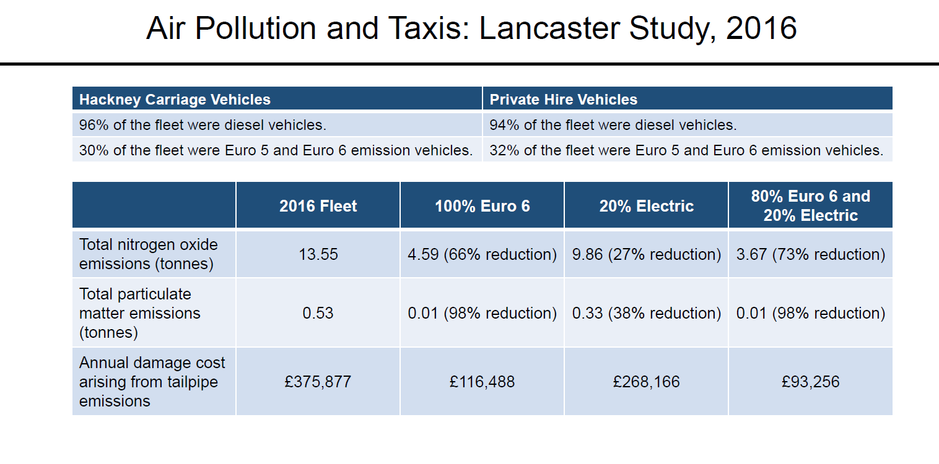

**Appendix B**

The bid group (Lancaster City Council, South Ribble Borough Council, Wyre Council, Rossendale Borough Council, Burnley Council and Fylde Borough Council) have agreed as part of the bid to work towards taking the following policies and incentives forward .West Lancashire Borough Council has also agreed, despite not being part of the final bid,  to take the policy proposals forward:-

|  |  |  |
| --- | --- | --- |
| Policy/Incentive Measure | Private Hire | Hackney carriages |
| All fleet Euro 6 compliant by 2022 (older vehicles can be retrofitted to meet Euro 6 emission standard) | Yes | Yes |
| All newly licensed vehicles to be a maximum 5 years of age when first licensed. Policy to apply from 2020. (this is the minimum policy requirement -  a tighter standard can be adopted if LA considers appropriate/in line with existing rules) | Yes | Yes |
| Only newly license zero emission taxis from 2028 | Yes | Yes |
| Provide new HC licence availability to zero emission vehicles  with disabled access (only for LA who limit HC numbers) | - | Yes |
| Using air quality or other council budget to pay for licence fee for zero emission taxis (available for 3 years from 2019) | Yes | Yes |
| Investigate the use of business rate relief for taxi operators running zero emission vehicles | Yes | - |
| Investigate the provision of local authority provided interest free/low interest loans to assist with the purchase of zero emission vehicle | Yes | Yes |
| Investigate opportunities for group procurement of zero emission vehicles to reduce purchase cost. | Yes | Yes |